**Director, ICTREC**

Application to host a Classroom for AGMT_2019 in FUNAAB for Nurses and Health Practitioners was submitted on the 15th January, 2019.

The AGMT was extended to the University as a result of her participation in the 2018 Introduction to Bioinformatics Training Course (IBT) organized by H3AbioNet, which is the same body organizing this training.

AGMT Application form is available at https://redcap.h3abionet.org/redcap/surveys/index.php?s=CHEJ9MCPPY.

Below are screenshots of the application form:

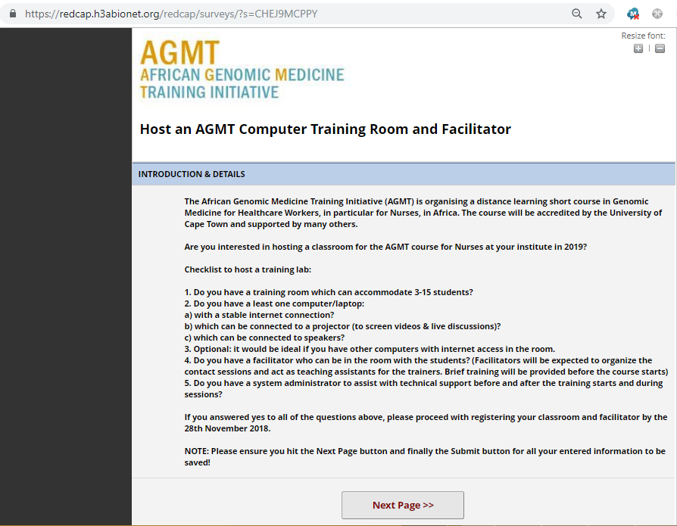

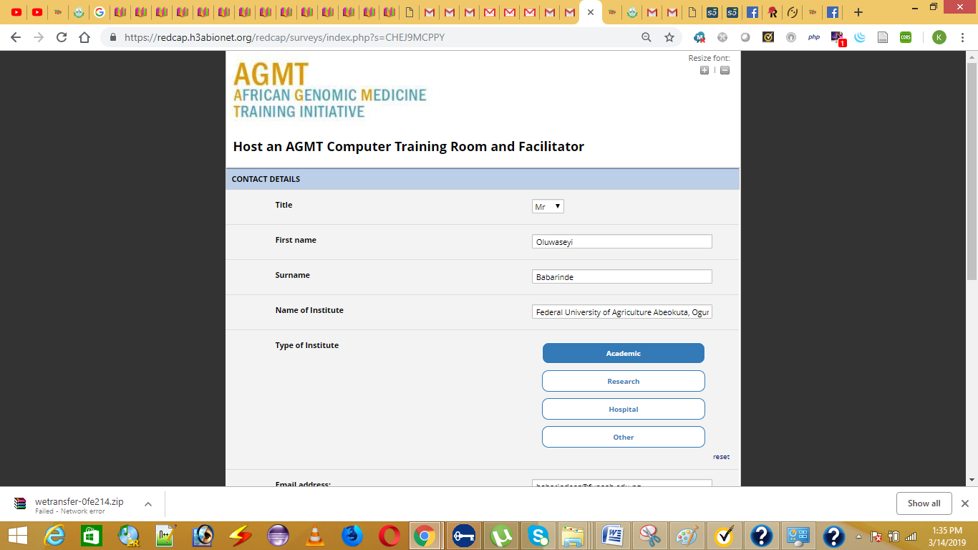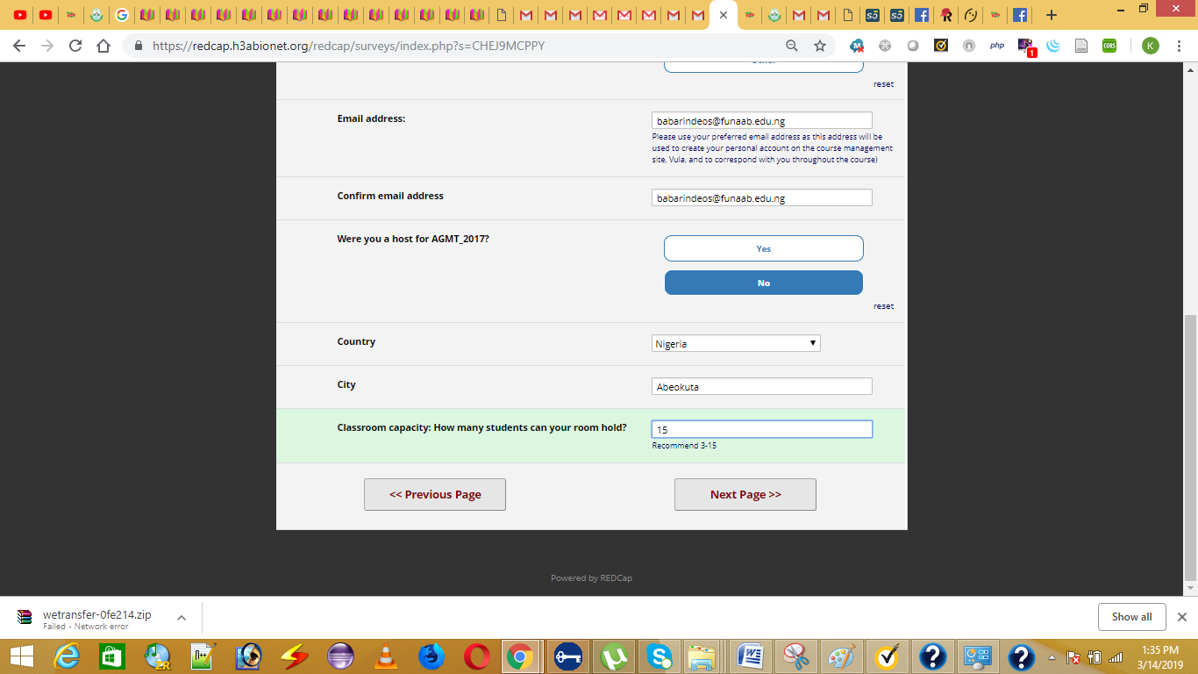

Other Classrooms in Nigeria are:

* NNPC Medical Centre, Lagos, Nigeria
* Centre for Advanced Medical Research and Training, UDUS, Sokoto, Nigeria
* Lagos State University College of Medicine, Ikeja, Nigeria
* University of Ibadan, Nigeria
* Federal Teaching Hospital Ado Ekiti, Nigeria
* National Hospital Abuja, Nigeria
* Nigeria Centre for Disease Control, Abuja, Nigeria

Attached is a copy of the call for application.

Thank you Sir.

Babarinde Oluwaseyi A.  
Senior Data Analyst,  
SP1706